



**User’s** **Guide**

March 2013

Version 1

Login to NursingCenter using your pre-assigned user ID and password. If this is the first time you are logging in, you will be prompted to change your password. Enter a personal password and continue.

You wilI be directed to your facility’s home page. To access CEConnection, click any of the Quick CE links. If you are accessing CEConnection for the first time, you may be prompted to complete your registration information. This information is used to complete your account and ensure that your certificates identify you correctly.

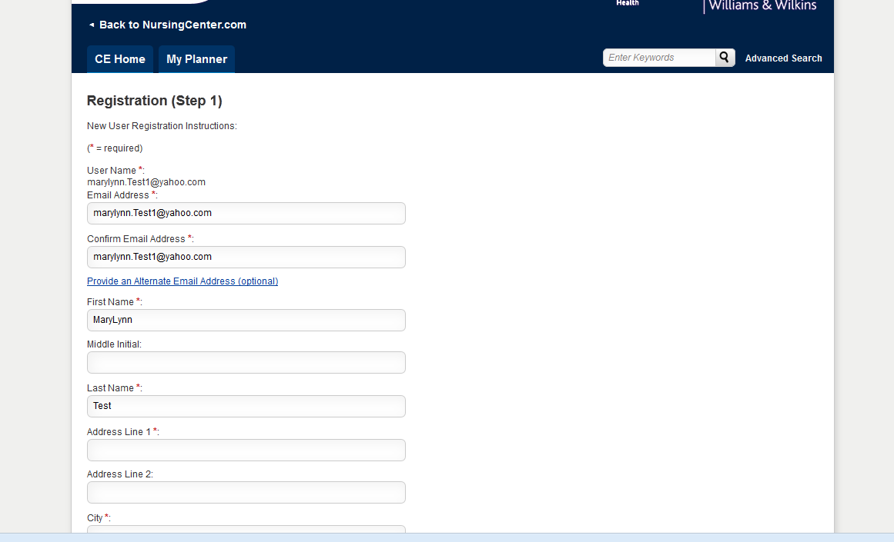

You may be asked to fill in additional information that was not originally entered on [www.nursingcenter.com](http://www.nursingcenter.com) registration/profile.

You will click the “**SUBMIT**” button to continue. You will then see the “CE Home” page similar to the example below.

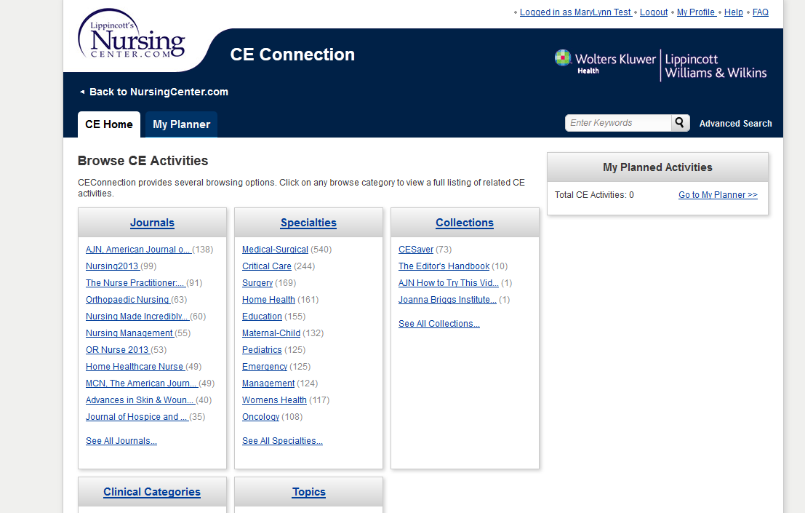

You are on “**CE Home**” and ready to browse and obtain contact hours from the extensive CE collection.

An easy way to find the CE you need is to use the various “Browse” CE activity classifications including:

* Journals
* Specialties
* Collections
* Clinical Categories
* Topics
* And more to come

When you locate the CE you would like to take, click on the underlined article title to take it now, or click on the **“+Planner**” button to save it for a later time. The activities for which you clicked “**+Planner**” will appear in both the "**My Planner**" tab and the "**My Planned** **Activities**” section on the right side of the Home Page. The activity will show the passing score, the expiration date of the activity, the contact hours, as well as other information.

**There are 3 steps in completing a CE test.**

***Step 1 -*** Scroll down the page to see “**Activity Steps**” and when you are ready to read the article, click on the underlined title under "Activity." You can print out the CE article to refer to as you take the test by clicking View PDF or View HTML.

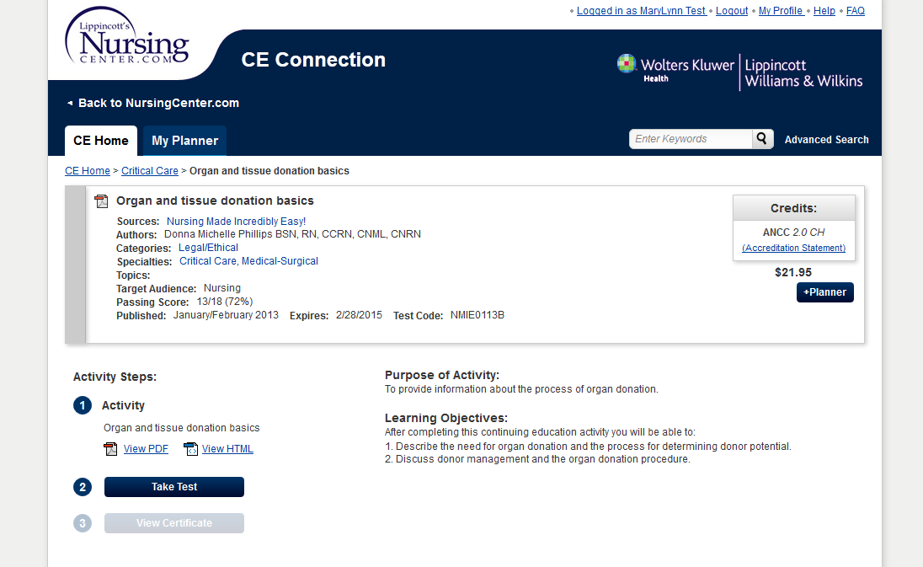

***Step – 2*** When you are ready to take the test, click on "**Take Test**." Use your mouse to click on the correct answer for each question. When you are finished taking the test, click “**Submit Test**”.

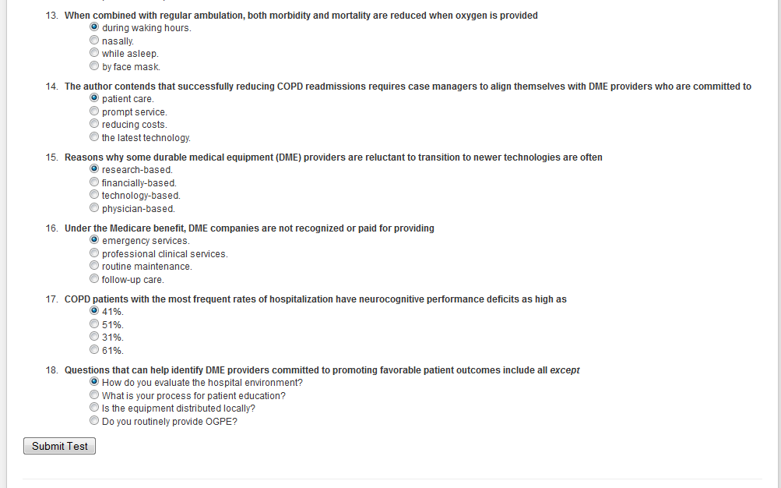

After you click “**Submit Test**,” you will be required to complete an evaluation form. The test is automatically saved after each question that you answer. You can access unfinished tests in the “My Planner” area under “In Progress.”

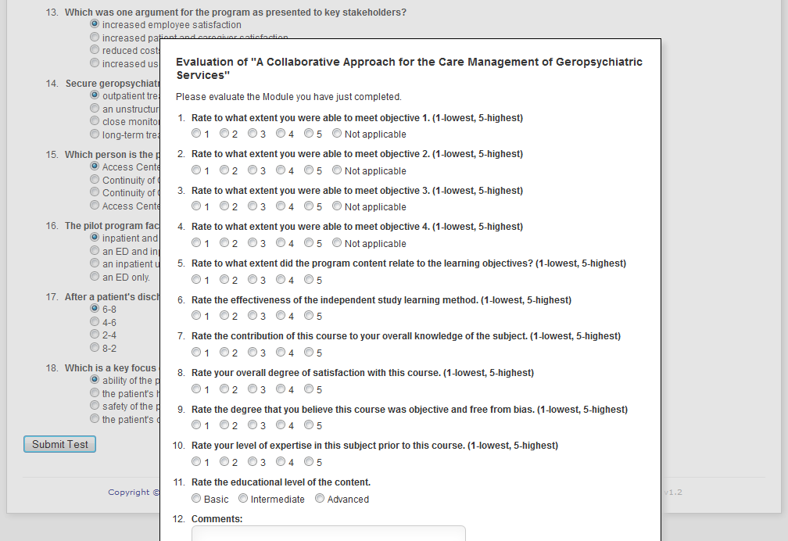

The next page will indicate whether you passed or not. If you have passed it will show you which questions you got correct. It will show you how many questions you answered correctly and what the passing score is. If you failed the test, you can retake it by clicking the button "**Retake**." You can take the test 2 more times.

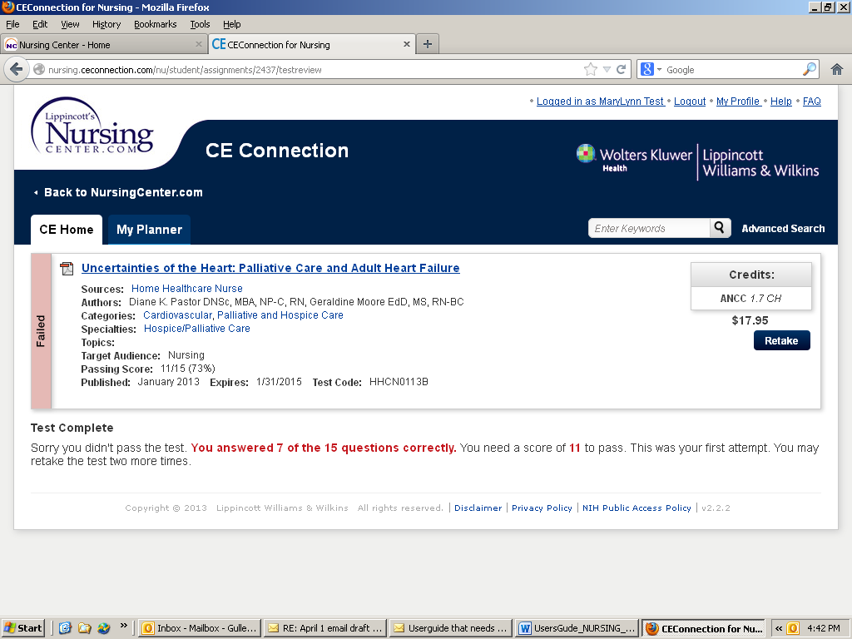

***Step 3*** is to pay for your CE Activity. You are not asked for payment unless you pass the test. After you pass your CE Activity, you will see a **“+Cart**” button on the right. Click on this to add this item to your Shopping Cart.

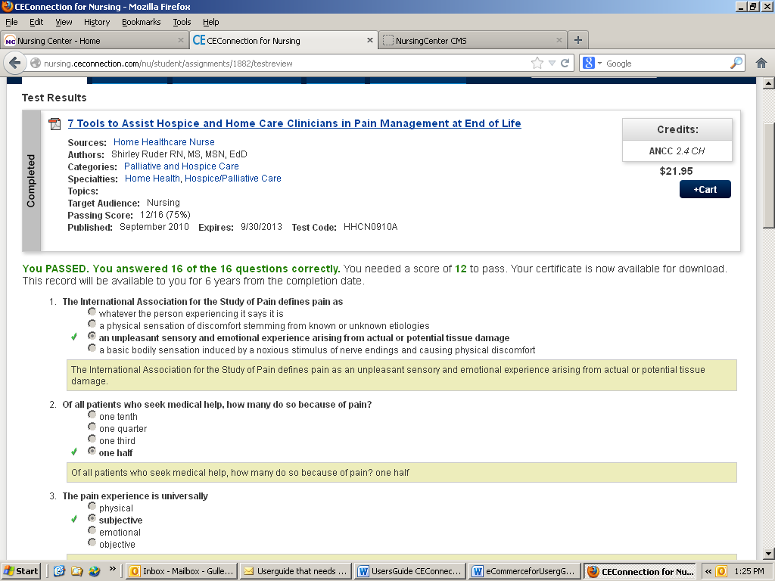

You will then see a Pop Up similar to the one below which shows that you have added the item to your Shopping Cart. You can either choose to Continue Shopping or Pay for your CE Activity by clicking “**Proceed to Checkout**. “

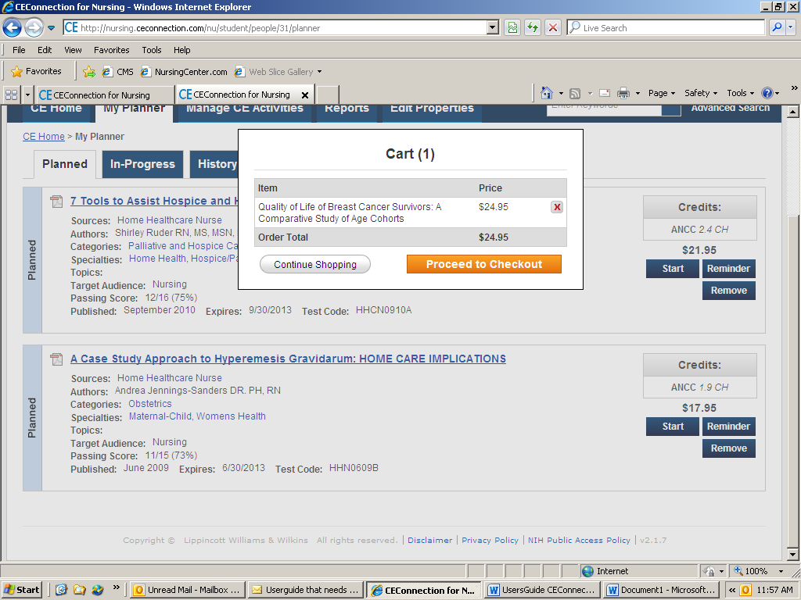

If you have been issued a Coupon Code or have a Promotion Code, enter it in the box and click “**Apply**”, otherwise click “**Proceed to Checkout**” to enter your credit card information. After you have entered the credit card information, click Purchase. You will receive a confirmation of your purchase in your eMail which you can print out as a receipt.

***Step 4*** is to “Print” your CE Certificate. Your certificate will appear as a PDF document in a pop-up window. You can print it, save it as an electronic document or refer to it in your Planner. Click on the “**Cert**” tab to view and print your CE Certificate. See a sample below. Click on the “Results” tab to see your test results.

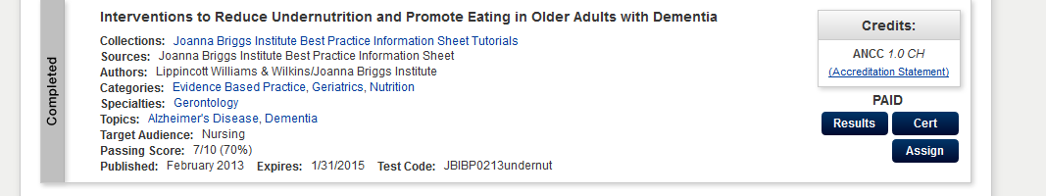

Here is an example of a CE Certificate.

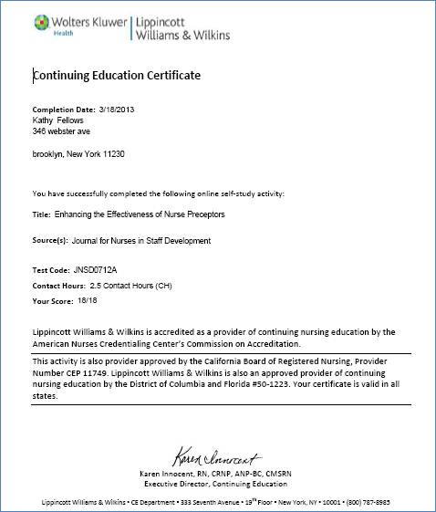

You can access your test results and your certificates from the “**History**” tab of the “**My Planner**” area any time after you complete a CE activity. Just click “**Cert**” or “**Results**.”

**Reviewing Your CE Activities.**

You can view all of your CE activities in the "My Planner" section by using the "Planned" and "In-Progress" tabs. Under the “In Progress” section, you can pick up where you left off in the CE test process by clicking "**Continue**," then "**Take Test.**" Remember, if you fail an Activity, you take it 2 more times.

The "History" tab will show your completed and failed activities.

**Setting Reminders to take a CE Activity Later**

When you want to set a CE Activity in your Planner to take at a later date, click the “Reminder” button.

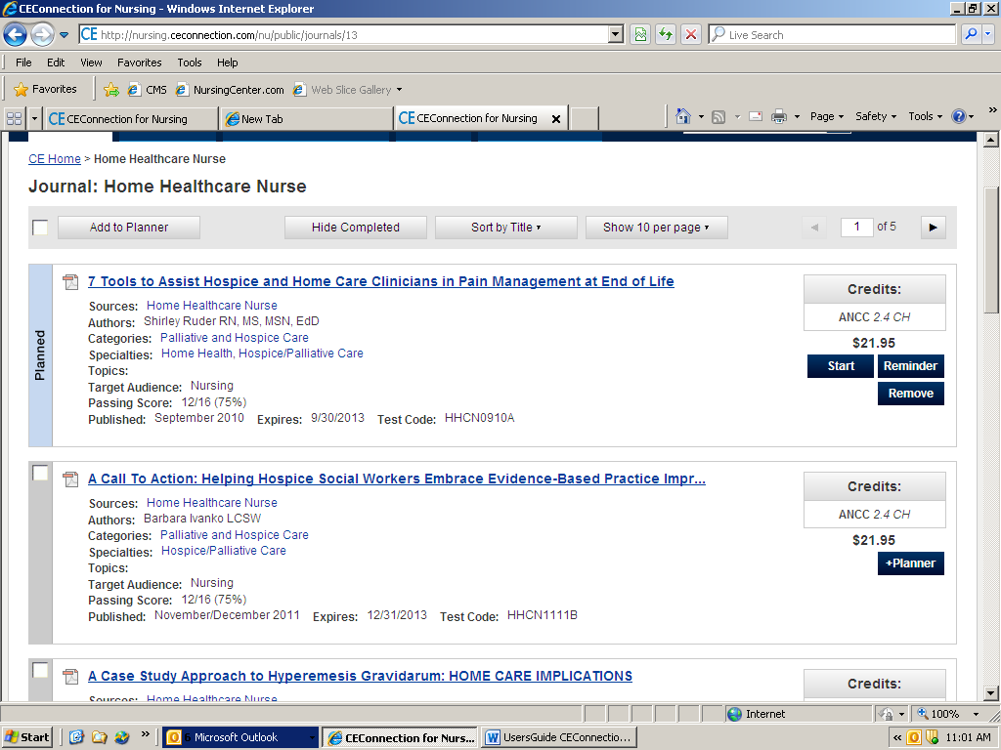

You can choose to be reminded once, daily or weekly beginning on a date you choose (see example below). On that date, you will receive a reminder in your eMail.

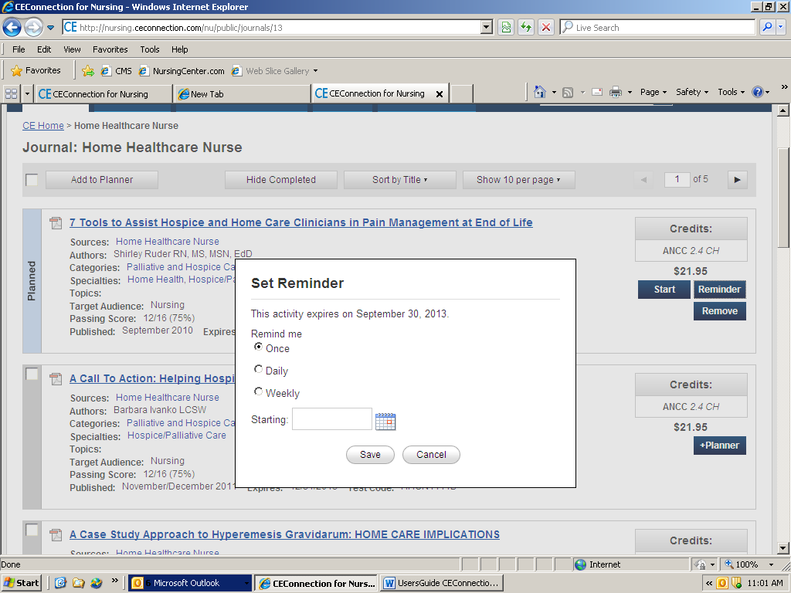

If you decide you want to remove a CE Activity from your Planner, simply click the “Remove” button.

**Technical Support**

For technical support or other assistance, please call toll free (800) 787-8985 or send an email to [CustomerService@wolterskluwer.com](mailto:CustomerService@wolterskluwer.com) Monday through Friday, 9am to 5pm ET.